AIVOA – Round 1 AI Product Engineer (Interns)

AI-Powered Customer Complaint Management System
Company Website: https://aivoa.ai

Objective
Build an AI-powered Customer Complaint Management System for the pharmaceutical manufacturing industry using the reference UI and demo video provided.

Before You Start
Before implementation, please:
- Watch the demo video completely.
- Read this assignment document.
- Research Quality Management System (QMS) used by pharmaceutical companies manufacturing API and FDF.
- Understand the purpose of the Customer Complaint module in a QMS.
We are not looking for domain experts. We are looking for curiosity, research, and problem-solving.

Mandatory Technology Stack
- Frontend: React UI with Redux for state management.
- Backend: Python with FastAPI.
- AI Agent Framework: LangGraph.
- LLMs: Utilize Groq(https://console.groq.com/docs/models), specifically the gemma2-9b-it model (assume you will create a new API token for this). You may also consider llama-3.3-70b-versatile for context.
- Database: MySQL/Postgres SQL
- Font: Google Inter.
- You may use Gemini 2.5 Pro (1-month free trial) or ChatGPT 5.0 for all coding and research, with zero human-written code.
Note: Do not simply copy and paste AI-generated code. Understand what the code does, then implement and adapt it to match the workflow shown in the demo.

Reference Material
Demo Video: https://drive.google.com/file/d/1av2lzDPx8YMSzTrIz7w51HTRWBz3_5Nj/view?usp=sharing

Reference UI Screenshot

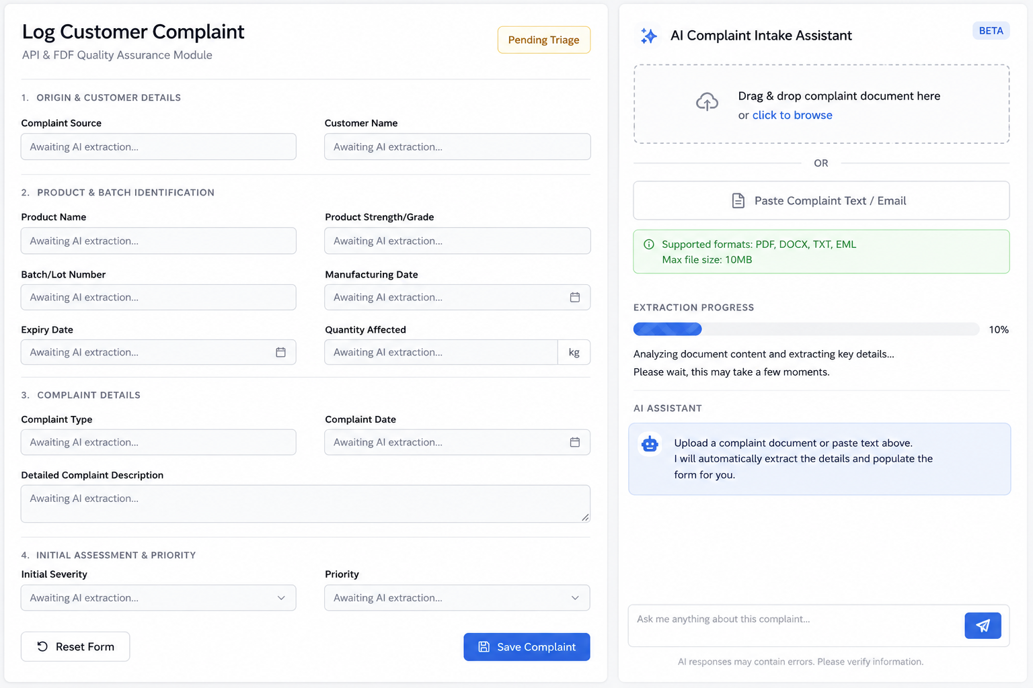

Implementation
- Follow the workflow demonstrated in the demo video.
- Use the mandatory technology stack.
- The UI doesn't need to match the screenshot exactly, but the demonstrated functionality should be implemented.
- You may create your own realistic pharmaceutical complaint PDFs, emails, or images for demonstration.
- Production-grade OCR or document parsing is not required.

Bonus Features (Optional)
Additional AI features are highly appreciated.
Examples:
- Complaint Completeness Checker
- Root Cause Recommendation
- Duplicate Complaint Detection
- CAPA Recommendation
- Complaint Summary
- AI Risk Classification

Deliverables
Submit your assignment using the link below:
Submission Form:
https://forms.gle/jdbgLTnuS6EAMSAP6
Include:
- GitHub Repository
- 5–10 minutes demo video explaining:(2 video submission)
  - Working demonstration of all implemented AI tools and frontend features.
  - Demonstrate and explain the code by walking through the complete end-to-end workflow, starting from the user's input (prompt or PDF/email upload) in the frontend, showing the relevant frontend code, API endpoints, backend processing, AI/LangGraph workflow, and finally how the response populates the Log Customer Complaint form and AI Copilot Risk Assessment.

Important Notes
- AI tools such as ChatGPT, Gemini, Claude, GitHub Copilot, Cursor, Windsurf, or similar tools are allowed and encouraged.
- Do not simply copy and paste AI-generated code. Understand what the code does, then implement and adapt it to match the workflow shown in the demo.
- During the interview, you should be able to explain your implementation and may be asked to modify or extend your solution.
- We value curiosity, clean code, product thinking, and problem-solving more than building a perfect application.

Good Luck!
We look forward to seeing your creativity and engineering skills.
Team AIVOA

